The Silk Hat Comes Into Fashion  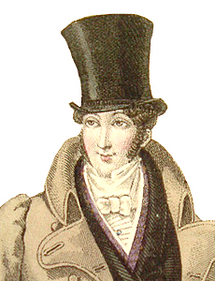 | The NWC and HBC Merger  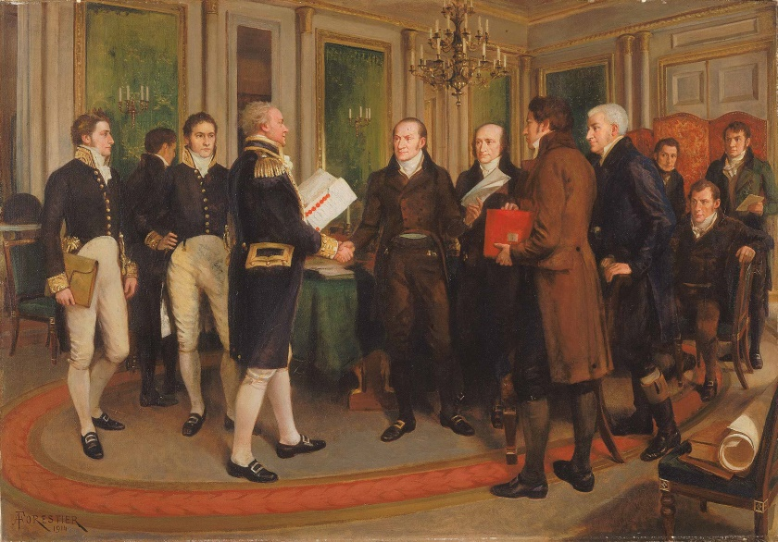
HBC Signs Deed of Surrender  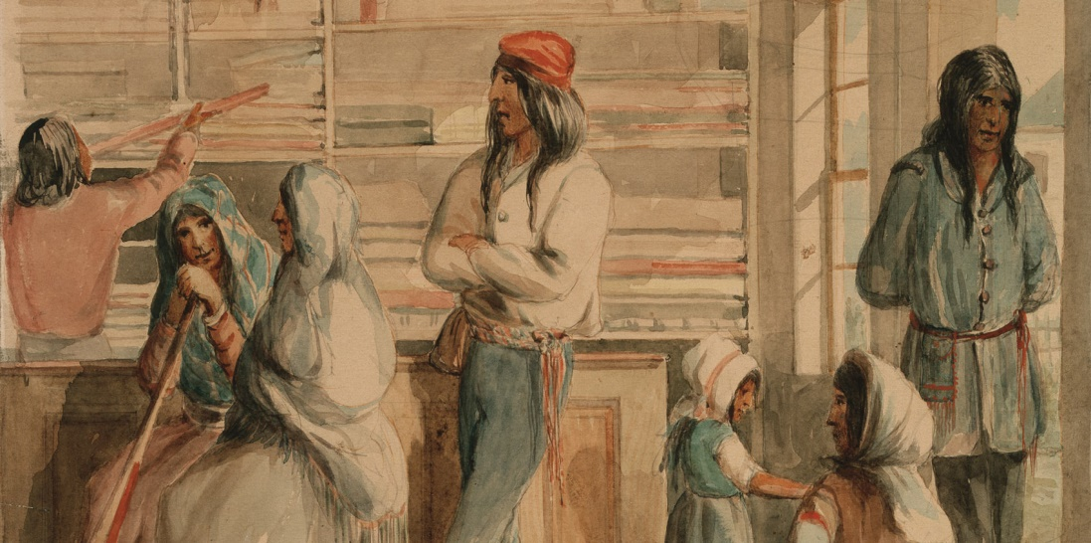 | The Beaver Almost Goes Extinct  